Name: _______________________

Student ID: ___________________

Date: ________________________

**Instructions:** Answer the following questions using complete sentences. You should use these questions to have a written discussion about the website you are going to design for the topic you submitted for Project Submission 1.

**1. Website Goal***Describe the goal of your website in one or two sentences.*

**2. What results do I want to see?***List the page name (that will be used in the nav section, e.g. Home, Yurts, Contact, etc.) and a brief description of that page on your site. You will need to have seven to eight pages listed.*

**3. What information do I need?**  
*List where you will obtain the content (facts, text, graphics, sound, video, etc.) for the web pages you listed above. If the information is from a website, list its url. Can’t just answered will google it. List out this information separately for each page you listed above.*

**4. What color scheme will you use for your site?**

*Go to paletton.com and select a color scheme your like. Play around with the different type of color combinations.* ***Choose a Triad or Tetrad combination, this will provide you will several colors for your website.*** *When you find one that you like, click “share palette” in the top right corner and* ***copy the Pallet UID and the image and paste them in the space below****. Example is on the next page.* You can also just do a screenshot to include the UID and the image.

**5. How will your project use a form?**

*Describe how you plan to use a form in your project to collect viewers’ inputs or information. Examples of using a form might be to offer feedback, provide a survey or poll, offer subscriptions to a newsletter, etc. Describe what information you will want to collect from your viewers and the importance of each piece of information.*

Color Scheme Example:

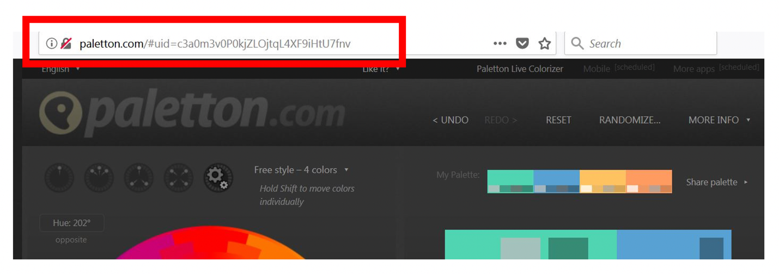

Palette UID: [6300E0kuDsfjIzJoXu+wmmFDMh-](http://paletton.com/#uid=6300E0kuDsfjIzJoXu+wmmFDMh-)

[](http://paletton.com/#uid=6300E0kuDsfjIzJoXu+wmmFDMh-)